MINUTES OF AN EXTRAORDINARY MEETING OF NORMANTON TOWN COUNCIL
Held on Monday 18th November 2019 at 10.00am at Normanton Town Hall

Present: Councillor D. Appleyard – Deputy Mayor
Councillor S. Hudson
Councillor F.D. Jones
Councillor Mrs H.W. Jones
Councillor Mrs L. Masterman
Councillor B. Mayne
Councillor Mrs A. Moran
Councillor K. Wilson, JP
Councillor W. Wood

West Yorkshire Fire & Rescue Service –
Nick Smith
David Teggart
Matt Walker

Councillors Absent: Councillor Mrs C. Appleyard, Councillor R. Best, Councillor Mrs E. Blezard, Councillor J. Botterill, Councillor Miss J. Farrar, Councillor Mrs F. Marchant, Councillor Mrs P. Mayne, Councillor Ms J. Medford, Councillor Mrs C.A. Moran, BEM, Councillor R. Seal, Councillor D. South, Councillor A. Wassell, Councillor Mrs A. Wood.

109. Mayors Welcome
In the absence of the Mayor, the Deputy Mayor chaired the meeting.

The Deputy Mayor welcomed everyone to the meeting and welcomed the representatives from the West Yorkshire Fire & Rescue Service.

110. Apologies for Absence
RESOLVED that apologies be received on behalf of Councillor R. Best.

RESOLVED that apologies be received and reasons approved on behalf of Councillors Mrs E. Blezard, J. Botterill, Miss J. Farrar, Mrs P. Mayne, Ms J. Medford, Mrs C.A. Moran, BEM, R. Seal, D. South, A. Wassell and Mrs A. Wood.

111. Declarations of Interest
Members were reminded of the requirement to make an appropriate declaration at the meeting on any item in which they had an interest.

There were no declarations made.

112. Fire Service Consultation
Nick Smith provided a detailed presentation on the proposals for the current consultation.

It was reported that the IRMP document was a three-year strategy which sets out how the Fire & Rescue Service manage risk and this document is reviewed annually.
There was no collective agreement in place for the current ‘Close Call’ duty system and this had been challenged in the courts and found to be unlawful.
Changes had to be made to ensure that the service were operating in a proper manner. The FBU were supportive of the proposed changes and discussions would be held after the consultation about the pay deal for the affected fire fighters.

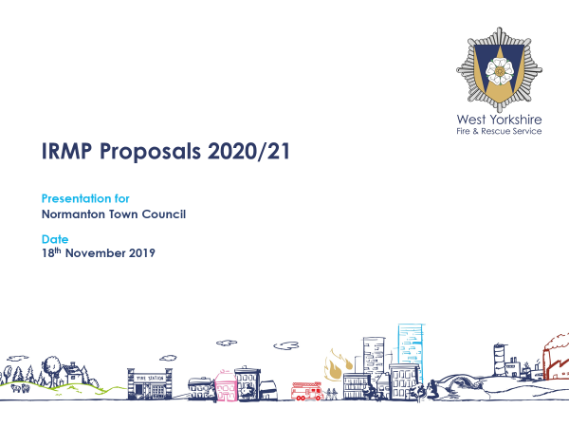
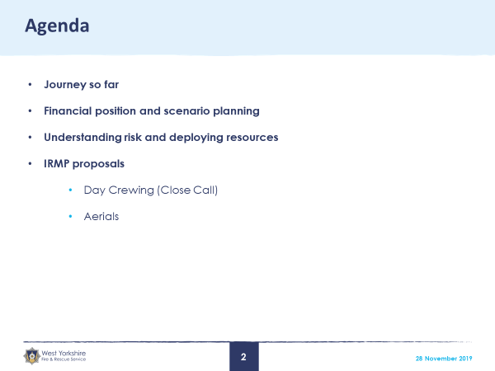

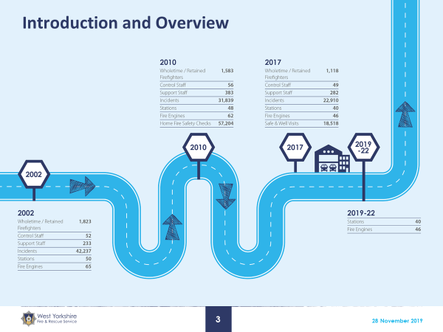
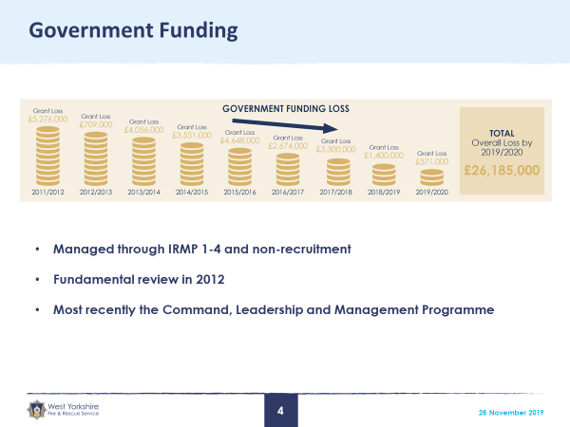

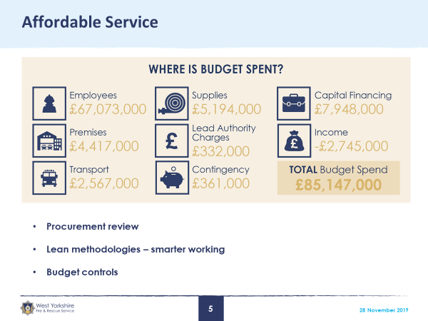
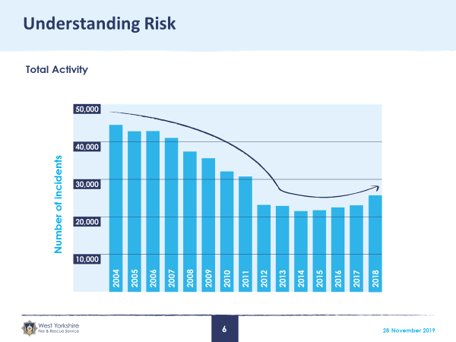

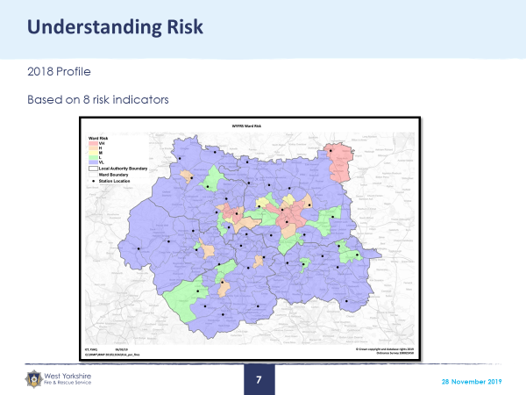
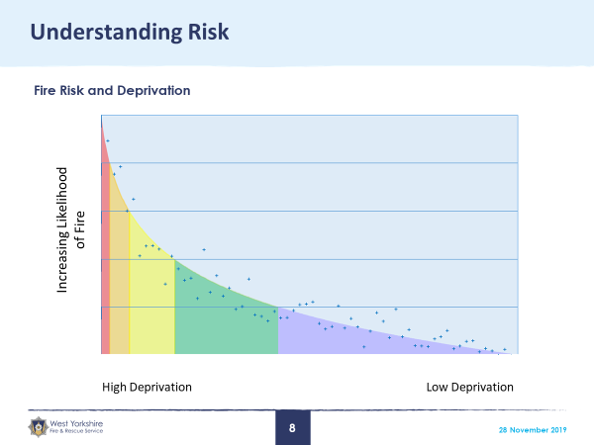

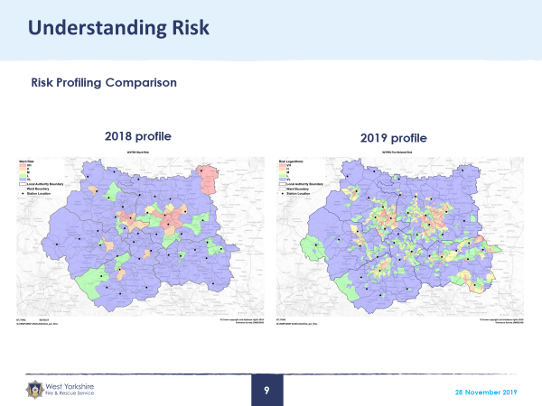
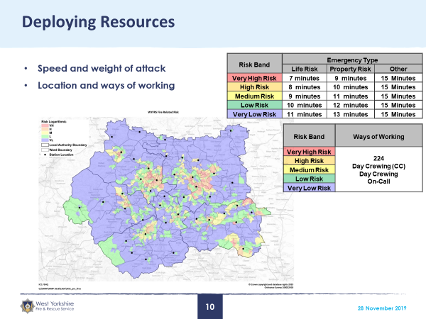

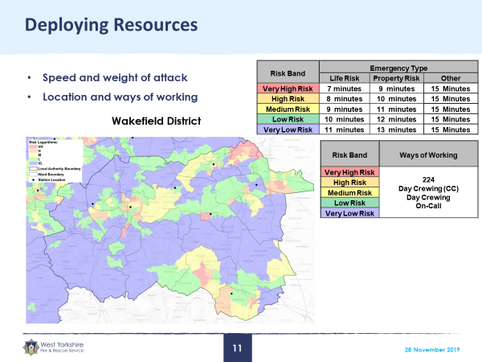
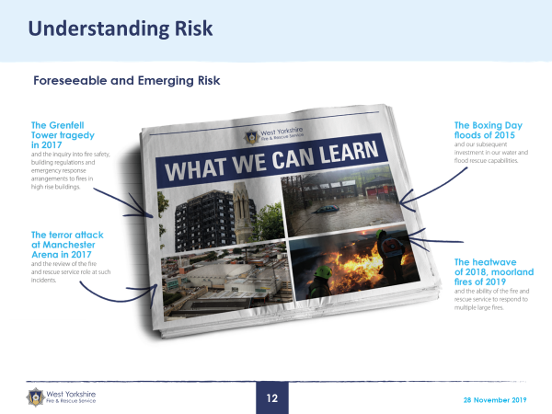

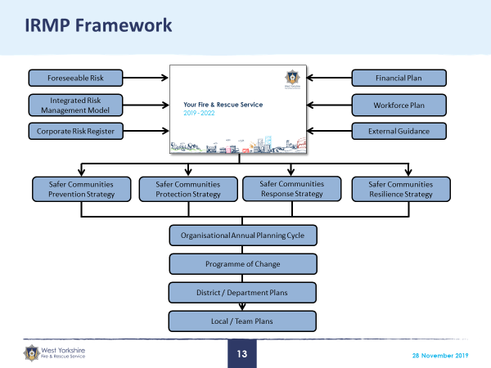
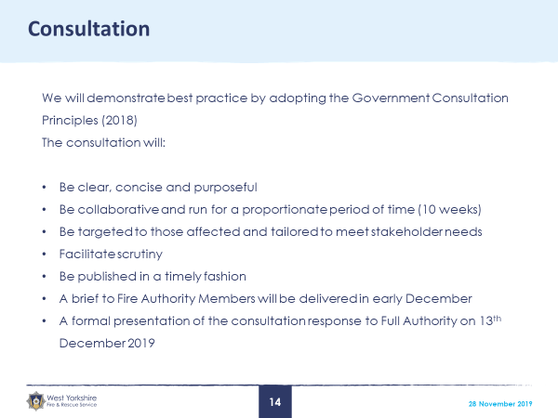

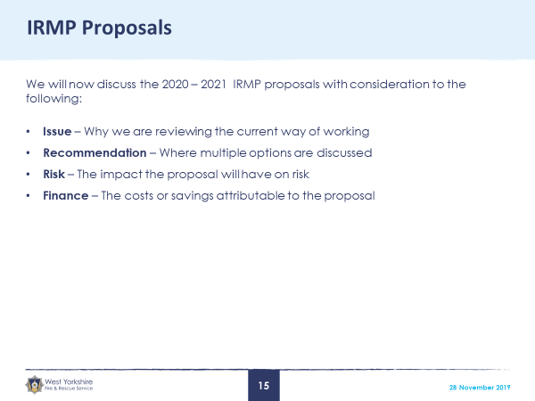
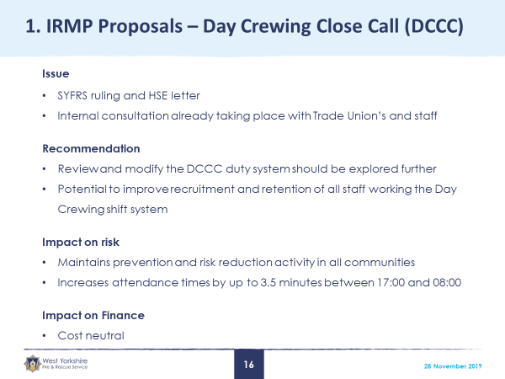

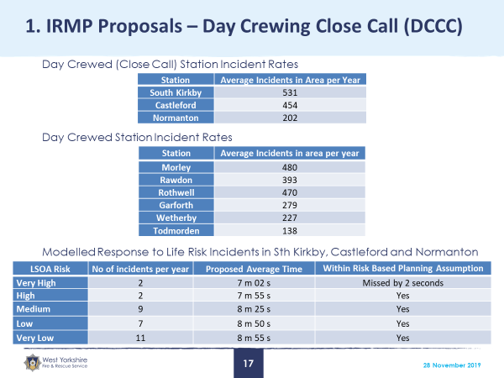

Members thanked the West Yorkshire Fire & Rescue Service for a very interesting presentation and agreed that they would not make any formal comments to the consultation.

In the absence of any further business, the Deputy Mayor thanked everyone for their attendance and closed the meeting.

